Project Report Approval for Bachelor of Engineering

This Project Report entitled Paradise Motorsports using Unity 3D by C2-17 group is approved for the degree of Bachelor of Engineering in Computer Engineering.

Examiners
- _______________

- _______________

Supervisors/ Guides
- _______________

- _______________

Head of Department
- _______________

Principal
- _______________

Date:
Place:

DECLARATION
We declare that this written submission represents our ideas in our own words and where others' ideas or words have been included, we have adequately cited and referenced the original sources. We also declare that we have adhered to all principles of academic honesty and integrity and have not misrepresented or fabricated or falsified any idea/data/fact/source in our submission. We understand that any violation of the above will be cause for disciplinary action by the Institute and can also evoke penal action from the sources which have thus not been properly cited or from whom proper permission has not been taken when needed.

Name of student Roll No. Signature
- Chandravadan Raut 13106B0063 _ _ _ _ _ _ _

- Kedar Patil 13106B0069 _ _ _ _ _ _ _

- Alok Singh 13106B0069 _ _ _ _ _ _ _

Date:

ABSTRACT
Paradise Motorsports
Windows is a widely-used operating system. As a result, windows gaming is also in demand. Game designing is a really interactive and creative part of modern IT culture. This has motivated various developers to create interesting games on windows platform. Thus, we aim to develop an entertaining and fun game. Our game is a single player game which provides multiplayer functionality as well. In the game, the player will need to have very good timing and speed in order to win. The objective would be to cross the path full of obstacles in given or shortest time. The difficulty of levels will Increase gradually as the game proceeds. Since it is a racing genre game, the multiplayer gaming will focus on races with your friends and let the users compete to be the best. Apart from this even time attack mode enables players to track and beat their own high scores. The platform of the game is Developed using Unity 3D game engine and main coding is in C#. The game needs to be constructed in a way that is organized and well planned to give the users the best experience possible. Thus, we will try to create a game which is extremely entertaining and intriguing with great graphics to make it visually appealing.

ACKNOWLEDGEMENT

It is a matter of great honor to bring out the seminar report on the project:
“Paradise Motersports”
We experience immense pleasure in stating that we have secured the excellent guidance of Prof. Prita Patil. We have received her whole-hearted assistance, inspiration, encouragement and valuable guidance in all phases of our project.
We also take the opportunity to thank Prof. Pankaj Vanvari for their valuable help.
Lastly, we cannot forget to thank our group members and our class friends who directly or indirectly gave us ideas and help for this project. Also, we are thankful to the non-teaching staff for providing the various facilities for this project

Table of Contents

CONTENTS
Sr. No. | Page Title | Page No.
 | Declaration | ii
 | Abstract | iii
 | Acknowledgement | iv
 | Table of Contents | v
 | Organizational Profile | 7
1 | Project Overview | 12
2 | Introduction and Motivation | 15
3 | Literature Survey | 19
4 | Analysis and Design | 30
5 | Project time and task distribution | 36
6 | Implementation | 38

7 | Test Cases
8 | Conclusion and Future Scope
9 | Bibliography

ORGANIZATION PROFILE

Unity 3D is a game engine used for developing games for multiplatform use. It is one of the best features of Unity to allow user to create a game able to run on multiple devices or systems. It makes use of extensive libraries which support many different game functions necessary. It is used for collaborating the animations, art, sound, functions and objects together to create the final product. The coding is mostly in C# and the inbuilt assets are easier to access. Unity can handle and support several art assets and file formats from Maya, Blender, Adobe Photoshop and Illustrator. All these assets are handled by Unity’s GUI (Graphical User Interface). They can be very easily added onto any project. Unity’s scripting is built on MONO which is basically the open-source implementation of the .NET framework. This project is purely on basis of entertainment purpose and we can sell this product in market and we will get good price out of it.

PROJECT OVERVIEW

The racing video game genre is the genre of video games, either in the first-person or third-person perspective, in which the player partakes in a racing competition with any type of land, air, or sea vehicles. They may be based on anything from real-world racing leagues to entirely fantastical settings. In general, they can be distributed along a spectrum anywhere between hardcore simulations, and simpler arcade racing games. Racing games may also fall under the category of sports games.
The new generation gaming is of VR (Virtual reality). When you get two people together in a virtual space, and you actually get to see how they move and how they talk, and how they interact with the world, it lets you connect as if you were really actually in that room with them. And it’s pretty powerful.
Types of gaming are generally same as that of movies because they have excellent story lines which are extremely capitative and may follow to number of episodes. General types are simulation, adventure, Real-Time Strategy, Puzzle, Actions, Drama, etc.

INTRODUCTION AND MOTIVATION

A video game is a specific type of software that runs on hardware, a computer or video game console. That hardware platform requires at least some memory (that can be in several forms), some processing capacity and ways to interact with a display and some method with which a player can control the game. Games will train and educate people, providing new skills and knowledge they can use outside of the game. An example is readily found in flight simulators, but even arcade racing games will train the player to manage more complex situations they will leave the player in an emotional and intellectually changed state. [6]
Our racing game will contain different inputs like tap, swipe and motion sensing on different levels. In the game, the player will need to have very good timing and speed in order to win. The objective would be to cross the path full of obstacles in given or shortest time. The difficulty of levels will increase gradually as the game proceeds. Since it is a racing genre game, the gaming will focus to compete A.I and the users fight in racing to be the best. Apart from this avoid hurdles players to track and beat their own high scores. The platform of the game is developed using Unity 3D game engine and main coding is in C sharp. Windows users have a desire not only for games in general, but for quality games that provide them entertainment and a level of challenge too. Thus, the game needs to be constructed in a way that is organized and well planned to give the users the best experience possible. Thus, we will try to create a game which is extremely entertaining and intriguing with great graphics to make it visually appealing.

In this report, we proposed racing game using C# in Unity 3D. In section II we have given importance of gaming , types of games , gaming history and benefits of 3D games over 2D games . A proposed system and steps involved are discussed in section III . A section IV gives implementation and analysis which contains features of Unity and our game. A section V gives experimental results with comparisons of different game engines and finally section VI gives conclusion of a proposed work.

LITERATURE SURVEY

  - Gaming Overview
The racing video game genre is the genre of video games, either in the first-person or third-person perspective, in which the player partakes in a racing competition with any type of land, air, or sea vehicles. They may be based on anything from real-world racing leagues to entirely fantastical settings. In general, they can be distributed along a spectrum anywhere between hardcore simulations, and simpler arcade racing games. Racing games may also fall under the category of sports games.
The new generation gaming is of VR (Virtual reality). When you get two people together in a virtual space, and you actually get to see how they move and how they talk, and how they interact with the world, it lets you connect as if you were really actually in that room with them. And it’s pretty powerful.
Types of gaming are generally same as that of movies because they have excellent story lines which are extremely capitative and may follow to number of episodes. General types are simulation, adventure, Real-Time Strategy, Puzzle, Actions, Drama, etc. [6]

  - Revolution of Games
The term video game has evolved over the decades from a purely technical definition to a general concept defining a new class of interactive entertainment. Technically, for a product to be a video game there must be a video signal transmitted to a cathode ray tube (CRT) that creates a rasterized image on a screen.
The history of video games spans a period of time between the invention of the first electronic games and today, covering a long period of invention and changes. Video gaming would not reach mainstream popularity until the 1970s and 1980s, when arcade video games, gaming consoles and home computer games were introduced to the general public. Since then, video gaming has become a popular form of entertainment and a part of modern culture in most parts of the world
Video games transitioned into a new era in the early 1970s [7] with the launch of the commercial video game industry with the display of the coin-operated arcade game Galaxy Game and the release of the first widely available arcade game Computer Space, and then in 1972 with the release of the immensely successful arcade game Pong and the first home video game console, the Magnavox Odyssey, which launched the first generation of video game.

  - Benefits of 3D Games over 2D Games
There are many advantages of 3D games over 2D games
3D games are easy to play for the new player. It is easy for the more than one player to play the 3D games with interest.3D games provide flexibility of adding real life details which helps player to understand gaming environment easily. Sport games, puzzle games and action type games are more popular amongst the gamers. Sport games are much popular amongst the users. 3D games give better visualization than the 2D games. It is looks very live than the 2D games. There are different types of game are developed in the 3D games designing platforms for the development.
That extra dimension makes the game development much harder and need many more resources. 2D sprites rendered onto simple quads turn into texture atlases rendered onto a large number of polygons in 3D. Animation in 2D is simply swapping the sprite on the polygon, whereas 3D requires a skeleton and a number of behavior animations. 2D physics is much simpler than 3D as well.
In a nutshell, 2D is much less resource intensive both in development costs and runtime resources (CPU, disk, etc) than 3D games.
Today, gamers typically enjoy the realism of 3D design. The believability of the games is provided through camera perspective as well as genre. 3D games tend to focus on war, racing, or playing sports, allowing the player to experience more realistic action.
This allows a new level of immersion that 2D never broached. Players feel what happens within the realm of the game is in harmony with the physics and gravity of their own world. The 3D design looks, behave and feels real – even when set in a fantasy world.

ANALYSIS AND DESIGN

The proposed game is a single player interface racing game with A.I vehicles. Its specifications are as given:

1 Game Name
Paradise Motorsports
2 Game genre
Racing type arcade game
Interface- keyboard.
3 Targeted Audience
Windows users of all age groups.
4 Delivery Platform-
The game will showcase of car racing tournaments.
5 Features and purpose –
There are tons of games available in the market. Our aim of developing the game is to make hard to play and interesting tracks. First run GarageScene:
you can select your car from this scene , all the cars are stored in array when you click on the next
button it will destroy previous car show next car listed in array on play button click .
Set playerPref according to the car selected index.
When we enter in new scene in TrackScene , first of all car will spawn the user is selected in previous seen by checking playerpref and spawn
that car according to index number. The RccCamera will find the object with tag "Car" in start function and save the transform in player variable.
All the cars have car controls scripts which includes number of gears, speed, torque and control sensitive. You can change it if you want and all the wheel attached with script which allow them spin according to speed. Currently we have different tracks. The game’s objective is to beat others and quickly clear each track to win the game. Further you proceed into the game more complex tracks and faster cars you unlock. Create your own strategy by analyzing tracks. Need great coordination to beat A.I.s. The actions for vehicles will be to turn left or right and accelerate or brake. The background will move ahead only on user input. Hence the user will need to give continuous inputs to keep the vehicle moving and reach the end line. Overall architecture of game is interactive and highly dynamic. The user should be prepared for all types of obstacles and react quickly. The graphics will be rendered to an aspect ratio of 16:9 and a vertical orientation will be the output. The game can be easily played on various resolutions and won’t have a problem with rendering objects.

A) Flowchart
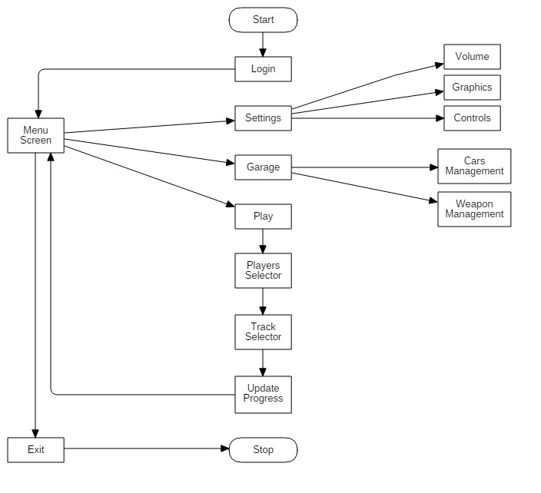

B) USE-CASE Diagram

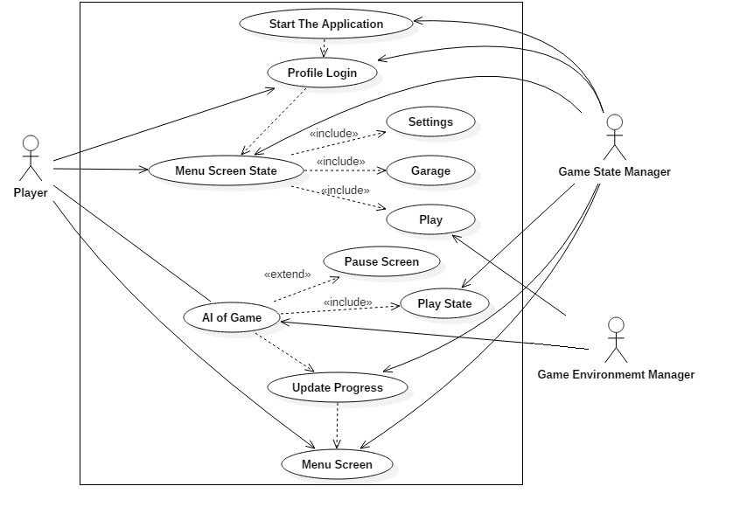

Design :

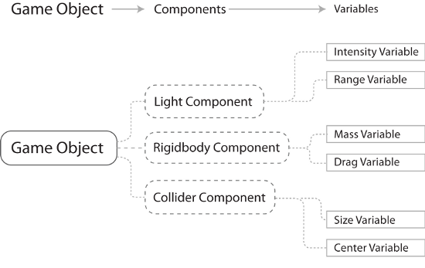

General steps

1. Initial Planning:
The pioneer of game development
process includes conceptualization of the gaming
idea. The game play, the age group, the ratings, game
mechanics are all decided in this phase of game
development. Various researches are also done to see
that the idea is unique and also that it can be
implemented.
2. Technical Requirements:
It includes deciding on the
platform based on the targeted audience. The tools
and the materials required for the game design are
also decided in this phase.
3. Deciding Game theme & genre:
Based on the game concept, the theme and genre are finalized. In our case, the genre is Racing .

4. Designing Game objects & environment:
Game objects are an integral part of game. In this phase, the
different game objects are designed using the various
softwares. [2]

5. Developing UI:
The user interface, the menu are
developed in this phase. [2]

6. Adding features & mathematics: Different algorithm
and mathematics are used for score calculation; these
features and algorithm are added in this phase. The
physics involved in the game is also added.( Example:
collision detection). [2][3][4]

7. Integrating steps: After the prerequisites of game are
developed. This phase includes integrating all the
phases to create a responsive and functional game.

8. Testing & fixing bugs: The developed game is tested
on android platform to see if the game features are
working well on the device. Also it is checked to see
it supports the various devices and android versions
Alpha-Beta testing is performed. If any problem is
encountered, it is rectified.

  - TECHNOLOGIES USED:
    - HARDWARE REQUIREMENTS:
    - Device: Personal Computer, Laptop, Smart Phone supporting Android OS, RAM memory: 512 MB
    - Processor: 1 GHz
    - SOFTWARE REQUIREMENTS:
- Operating system: Windows Xp and Higher
- Executable file.

PROJECT TIME AND TASK DISTRIBUTION

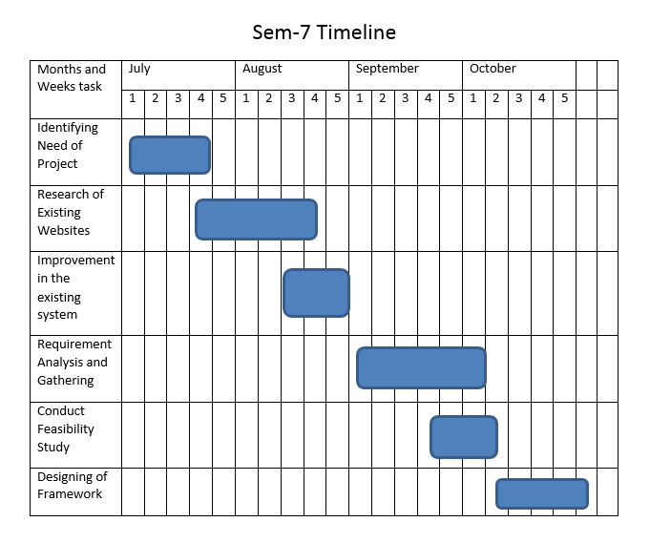

8th Semester Timeline

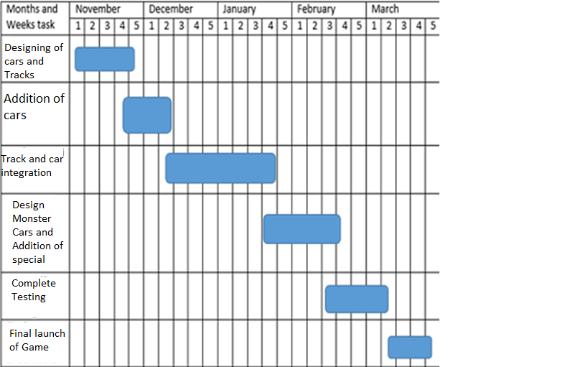

IMPLEMENTATION

- What is Unity 3D?
Unity 3D is a game engine used for developing games for multiplatform use. It is one of the best features of Unity to allow user to create a game able to run on multiple devices or systems. It makes use of extensive libraries which support many different game functions necessary. It is used for collaborating the animations, art, sound, functions and objects together to create the final product. The coding is mostly in C# and the inbuilt assets are easier to access. Unity can handle and support several art assets and file formats from Maya, Blender, Adobe Photoshop and Illustrator. All these assets are handled by Unity’s GUI (Graphical User Interface). They can be very easily added onto any project. Unity’s scripting is built on MONO which is basically the open-source implementation of the .NET framework.
Unity tools are given below.
Diagram / Graph drawing:
- MS Visio: highly recommended!
- Free Mind - Free Mind Mapping Software. If you don't know what mind mapping is I highly recommend you learn!
Writing:
- CelTX: Free web-based scriptwriting tool
- Scrivener: Writing tool

Image Editing:
- Photoshop: Probably the most wide-spread option in the game industry
- GIMP: Free alternative to Photoshop, with plenty of features!
- Paint.Net: Intended as a free replacement to the basic Paint program in Windows

3D Modelling:
- Blender: Free 3D modeling with lots of great features
- Sketch up: Free 3D modelling tool aimed at architecture. Can be very useful to quickly draw some level designs or layouts!

Screen Capturing:
- ScreenPresso - For capturing screen shots, design ideas, gameplay, mockups, errors.
- Puush: Capture screenshots of active window or a selectable area, automatically copies link

File Sharing:
- Dropbox: get up to 50GB for free when also installing the app on your smartphone! Also, automatically syncs local files between multiple devices (referral link, get 0,5GB extra!)
- Google Drive: get 15GB for free with your Google account (but online created documents don’t use this free space)

Misc.:
- Audacity - Free Audio Editing & Recording Software

- Game States
- Game Menu, which has 2 states and exit option.
- Game menu has option to modify your car and upgrade it in ‘Garage’ state.
- In garage state, user can go into racing mode which is the actual gameplay. User can select his/her preferred car and race with it.
- While in gameplay state, there is one more game state which can be accessed by pressing ESC button on the keyboard.

V. EXPERIMENTAL RESULTS AND DISCUSSION

A. Comparison between Unity 3D and Others Game Engines
 | UNITY 3D | UNREAL ENGINE 4 | GAME MAKER
Full  3D support | Available | Available | Not Available
Full  2D support | Available | Not Available | Available
Free version | Available | Not Available | Available
Paid Version | Available | Available | Available
PC Export | Available | Available | Available
HTML5 Export | Not Available | Not Available | Available
Available on windows | Available | Available | Available

- Screenshots
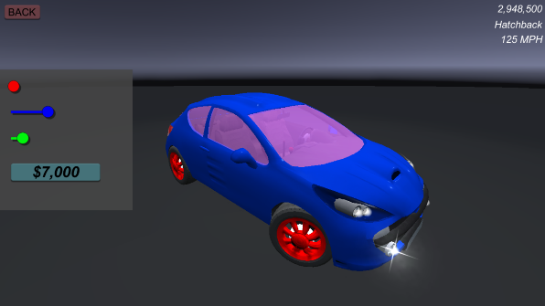
Figure 5.1 Garage

Here, as shown in fig 5.1, we can change color of rim, interior, glass and car itself in exchange of game credits. This garage can be used for upgrading the car.

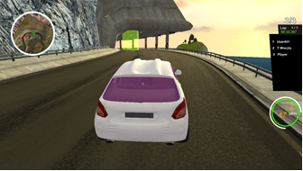
Figure 5.2 Racing track

Fig 5.2 shows the track which includes complex turns, tunnels and good graphics terrain.

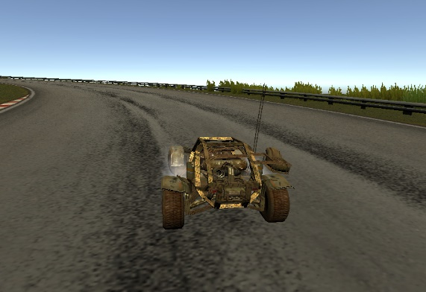
Figure 5.3 Racing Track

Fig 5.3 shows the track which includes sharp turns, rough roads and good graphics terrain.

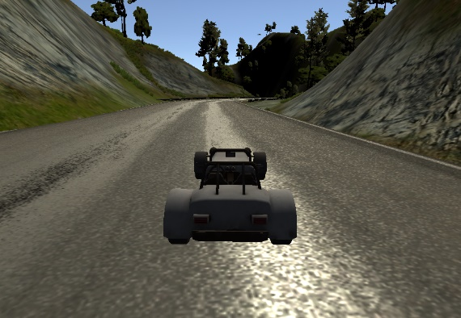
Figure 5.4 Racing Track

Fig 5.4 has a track in mountainous region with good graphic background.

CONCLUSION AND FUTURE SCOPE

In this paper, a suitable automated web based application system is designed. The principle idea of the System is used as platform in Medical field to fill and manage requirements of doctors as well as patients, automate major back end processes using Content Management System that helps any non-technical person to manage the system. Utilization of services (performance evaluation and knowledge forum) improves overall efficiency of System and provides user satisfaction.

REFERENCES

[1] LeBlanc, M. 2004b. Mechanics, Dynamics, Aesthetics: A Formal Approach to Game Design. Lecture at Northwestern University, April 2004.
Available online at:
http://algorithmancy.8kindsoffun.com/MDAnwu.ppt

[2] mybringback. “Tutorial Beginning 3D Game Development
with Unity.”
https://www.youtube.com/playlist?list=PL506E2704E1C1B387

[3] Queries - http://stackoverflow.com/
https://unity3d.com/learn/tutorials

[4] Freenodes former and current unity 3d and c++ game developers’ chathub http://irc.lc/freenode/unity3d

[5] “Unity” http://unity3d.com/[ONLINE]
http://unity3d.com/

[6] Video games history and Old games
https://en.wikipedia.org/wiki/Video_game_development
https://en.wikipedia.org/wiki/History_of_video_games

[7] Evolution of racing games, inspiration and motivation https://www.youtube.com/watch?v=uDS7gEhPGEI

